Trisia Baltazar

Due: Sep 18

CIS 310-02-4178

Assignment 4

Part 1

|  |  |  |
| --- | --- | --- |
| **TABLE** | **PRIMARY KEY** | **FOREIGN KEY(S)** |
| EMPLOYEE | EMP_CODE | STORE_CODE |
| STORE | STORE_CODE | REGION_CODE, EMP_CODE |
| REGION | REGION_CODE | NONE |

|  |  |  |
| --- | --- | --- |
| **TABLE** | **ENTITY INTEGRITY** | **EXPLANATION** |
| EMPLOYEE | YES | PRIMARY KEYS ARE UNIQUE AND NO KEY ATTRIBUTE IS NULL. (EMP_INITIAL IS NOT A KEY ATTRIBUTE) |
| STORE | YES | PRIMARY KEYS ARE UNIQUE AND NO KEY ATTRIBUTE IS NULL. |
| REGION | YES | PRIMARY KEYS ARE UNIQUE AND NO KEY ATTRIBUTE IS NULL. |

|  |  |  |
| --- | --- | --- |
| **TABLE** | **REFERENTIAL INTEGRITY** | **EXPLANATION** |
| EMPLOYEE | YES | STORE_CODE |
| STORE | YES | REGION_CODE, EMP_CODE |
| REGION | NA | NONE |

Part 2

Step1: Product

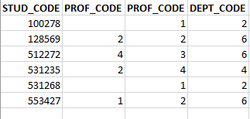

Step 2: Select

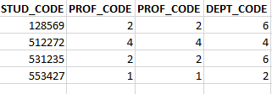

Step 3: Project

